Project back-end

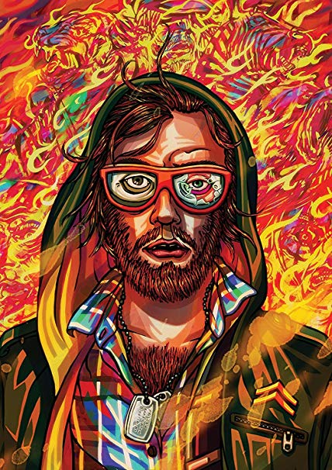

Namen: Netanel Dorothea, Patrick Devilee, Wendy Segaar

Studiejaar: 2018/2019

Werkgroep: 1

Projectleider: M. Boukiour

Inleverdatum:

Versie:1.0

Inhoud

1 Hoofdstuk 1 3

2 Hoofdstuk 2 3

# 1 Hardware

|  |  |
| --- | --- |
| Device | Minimum Systeem vereisten |
| PC of laptop | Windows : 7, 8.1, 10 64-bit  8 GB RAM  Intel core i3-8300 3.7 ghz  Intel® UHD Graphics 630  160GB SSD atleast 2gb + 1.5 gb cache available  Computer mouse  Keyboard  Extra pc screen |
| Smartphone | Qualcomm® Snapdragon™ 660 2.2Ghz  4 GB RAM  4GB storage space |
| Internet | Wireless network adapter of Netwerk kabel |

# 2 Software

|  |  |  |  |
| --- | --- | --- | --- |
| Software | Versie | Toelichting | |
| Laravel | 5.6 |  | |
| Google Chrome | 75.0.3749.0 |  | |
| Firefox | 48.0, 51.0.1, 62.0 |  | |
| Edge | 44.17763.1.0 |  | |
| Opera | 58.0.3135.117 |  | |
| PHP | 7.2 |  | |
| PHPstorm | 2018.3.3 |  | |
| Xammp | 7.2 |  | |
| Visual paradigm | 15.0 |  | |
| Microsoft word | 1809 |  |  |
| Github | 1.6.5 |  |  |
| Intellij | 2018.3.5 |  |  |
| Mysql workbench | 8.0.15 |  |  |